Industrial Mini PC
QY-B5610
Rich Configuration Series

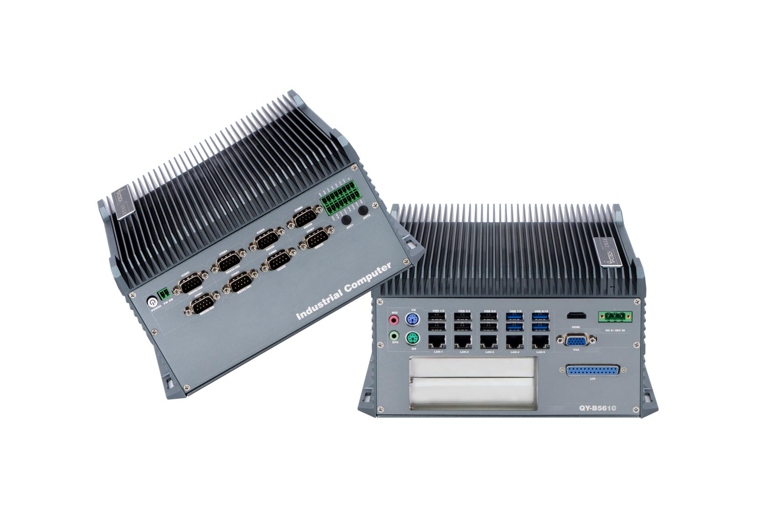

Products Features:
- Industrial-Grade Embedded Fanless Mini PC
- Intel Core 6 / 7th-i3 / i5 / i7 CPU
- 5*LAN, 10*USB, 8*COM, 1*HDMI, 1*VGA, 14*GPIO
- 2*Mini PCIE Expansion Slots, Support 4G and WIFI Module
- 1*PCIE 16X or 2*PCI Slots
- DC 9-36V Power Input With Overvoltage Protection
- -30℃~70℃ Temperature Can Keep 24/7 Work Stably
- Anti-Static, Anti-Pulse, Anti-Surge, Anti-Radiation
QY-B5610
1.Mother Board Specification:
Model | QY-B5610 | QY-B5610-12C
CPU | i3-6157U  i5-7200U / 7267U  i7-7500U
Memory | 1*DDR IIII RAM Slot, Up to 16GB
Storage | 1*MSATA SSD Slot  2*SATA SSD Slots
Display | 1*HDMI: Resolution up to 4096*2304@60Hz  1*VGA: Resolution up to 1920*1200@60Hz
Expansion | 2*Mini PCIE Slots, Support 4G and WIFI module  1*PCIE 16x slot or 2*PCI slots
Ethernet | 5*Intel i210V LAN Chip (10 / 100 / 1000 Mbps, RJ-45 Type)
USB | 4*USB 3.0 (Type-A)  6*USB 2.0 (Type-A)  2*PS/2
COM | 4*RS-232 / 422 / 485 (DB9 Type)  4*RS-232 (DB9 Type) | 4*RS-232 / 422 / 485 (DB9 Type)  8*RS-232 (DB9 Type)
GPIO | 8 ports GPIO (4*GPI+4*GPO, Phoenix Terminal Type)
Audio | 1*Line-In+1*Line-Out

2.Device Specification:
QY-B5610
Watch Dog | Support
Power Input | DC 9-36V With Overvoltage Protection
Power Input | Support Auto-Start
Power Input | 3 Pin Phoenix Terminal Type DC Plug
Working Temperature | -30℃~70℃, Support 24/7 Working
Structure | Fully Enclosed Aluminum Alloy Material
Heat Dissipation | Fanless Design, Conduction Heat Dissipation
Installation | Desktop / Embedded / Wall Mount
Size | 236mm*220mm*109.6mm
System | Windows and Linux

QY-B5610
3.Ordering Information:
Model | CPU | LAN | USB | COM | Display | RAM | SSD | Expansion | Power
QY-B5610 | 6th / 7th | 5 | 10 | 4*RS-232/422/485  4*RS-232 | 1*HDMI  1*VGA | 1*DDR 4  Up to 16GB | 1*MSATA  2*SATA | 2*Mini PCIE  PCIE 16x or  PCI | DC 9-36V
QY-B5610-12C | 6th / 7th | 5 | 10 | 4*RS-232/422/485  8*RS-232

4.CPU Information:

CPU | Specification
i3-6157U | 2 core, 4 total threads, 2.40GHz, 3 MB cache | Max to 16GB for 1*RAM 4 slot
i5-7200U | 2 core, 4 total threads, 2.50 GHz to 3.10 GHz, 3 MB cache | Max to 16GB for 1*RAM 4 slot
i5-7267U | 2 core, 4 total threads, 3.10 GHz to 3.50 GHz, 4 MB cache | Max to 16GB for 1*RAM 4 slot
i7-7500U | 2 core, 4 total threads, 2.70 GHz to 3.50 GHz, 4 MB cache | Max to 16GB for 1*RAM 4 slot

5.System Information:

CPU | System
6th / 7th | Windows 7 / 10 and Linux

QY-B5610
6.Fittings Information:
RAM | DDR 4 | 4GB / 8GB / 16GB / 32GB
Storage | MSATA | 64GB / 128GB / 256GB / 512GB / 1TB
Storage | SATA | 120GB / 128GB / 240GB / 256GB / 480GB / 512GB / 960GB / 1TB / 2TB / 4TB
GSM Module | 4G | 4G+GPS
WIFI Module | 7260AN / 7260AC / AX210

7.Package List:

Adapter | 1*12V 7A Adapter
Power Cable | 1*Power Cable
Terminal | 2 Pin phoenix terminal for Power Switch

8.Dimensions:
QY-B5610

